Bookstore Database Project Final Report

|  |  |  |
| --- | --- | --- |
| Name | ID | e-mail |
| نيفين عبد الفتاح حسين | 20201897 | Neveen_20201897@fci.helwan.edu.eg |
| رضوى مدحت | 20201829 | Radwa_20201829@fci.helwan.edu.eg |
| نادين سراج جمال الدين | 20201890 | Nadeen_20201890@fci.helwan.edu.eg |
| ندى ايمن محمود | 20201894 | Nada_20201894@fci.helwan.edu.eg |
| زينه عصام محمود | 20201831 | Zeina_20201831@fci.helwan.edu.eg |
|  | | |

**.Introduction:**

The product of this project is a database that stores the essential data for a supposed bookstore. It’s a core part in the management of the business. Naturally it mainly stores information about the books being sold in the store among other things, such as the book publisher/supplier and the customers who do business with the store. A lot of other relations were considered to be added to the database during the development process, but most of them were given up either because their information was far too simple to be added to the database, they were not expected to change, or were not essentially related to anything else in the database.

**.Development:**

First step was brainstorming the idea for the database and deciding an outline for its functionalities, wrote the scope, made an ERD after settling on a set of entities and their attributes, and then mapped it into a schema. We used SQL to create a small part of the database and discovered some mistakes through that process. Since this database is small we were easily able to go back and make some essential changes to the ERD and schema. After we made sure everything was correct, we used SQL to implement the whole database (specifically DDL), and DML as queries for data retrieval.

**.Entities, Attributes, and Relationships:**

The main and core relation in this database is **books**. The database stores information about **books** and everything related to them: Title, a distinctive ISBN, type, genre (sci-fi, history, young adult, etc..), author, edition, publication year, price, language, translator and translated language if the book is translated, and amount in inventory.

Inventory was supposed to be an independent relation in the beginning, but it was decided against because it was too simple to have its own relation, and so it became an attribute in **book**.

Storing the **book** sales was considered but eventually abandoned as it served no real purpose and did not align with the main theme of the database, which is more focused on the **customer** purchases and **publisher** orders.

**Authors** and **Translators** names (first name, last name) are stored in the database, in addition to the author’s country and birth year, which are pretty useful identifying tools when it comes to grouping books or literature eras/languages. All **books** have **authors**, but not all **books** have **translators**.

**Customers** name (first name, last name), contact info (phone number, e-mail), and address (city, area, street, building number) are all stored. That data is connected to the invoices produced each time a customer makes a purchase from the bookstore. Data/attributes of each invoice (relationship of customer buys books) includes date, quantity of each book purchased, and total price that was paid by the customer. **Customers** can buy multiple books at a time and produce multiple invoices. (Genre) preferences is a removed attribute from the relation **customer** because not all customers are essentially regulars.

**Publishers** name, contact info (phone number, e-mail), address (country, city, area, street, building number) are stored in the database. That data is connected to the orders that the bookstore requests from publishing companies. Data/attributes of each **order** includes the date, and the attributes of the relationship “order has books” are quantity of each book requested plus the total amount of all books, price of each book, and total price that’s to be paid by the bookstore.

The **publisher** entity also has a relationship with the **book** entity because the publishing house of a book is essential information about that book.

**ERD**

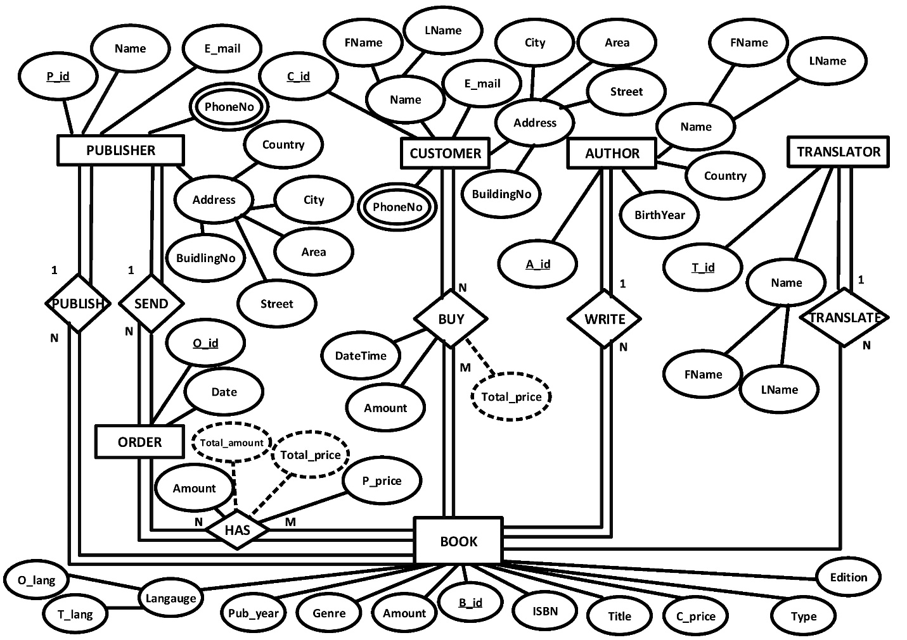

**Schema**

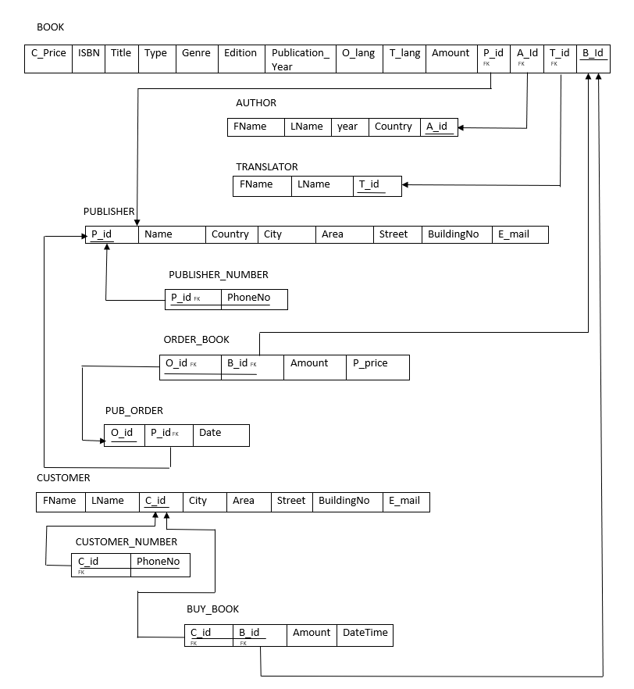

**DDL & DML**

